**LAB-4**

**Boolean Expression and Simplification**

Name.

Reg. No.

**Equipment:**

Explorer Board

**Software:**

Circuit Maker, Waveforms

**Components:**

IC Type 7408 QUAD two input AND gate

IC Type 7432 Two input OR gate

IC Type 7404Oneinput NOT gate

**Description:**

The Digital Systems should be able to perform operations on the binary number. The simplest operations that come to mindare the arithmetic operations like add and subtract.As the logicgates operate on binary values therefore these function tables describe the relationshipbetweenthe input and output in terms of binary values.

**Objectives:**

* To understand working of gates
* To Implement gates on explorer board
* To Validate the above implementation using Circuit Maker

**Lab Task 1:** Consider the given circuit

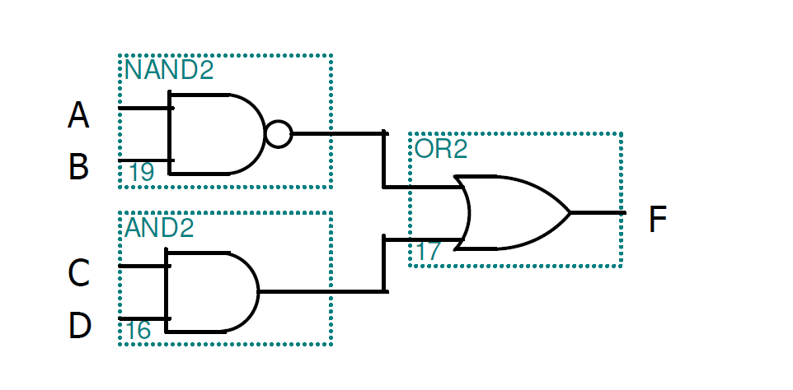

1. Create and fill the Truth Table for F

|  |  |  |  |  |  |  |  |
| --- | --- | --- | --- | --- | --- | --- | --- |
| A | B | C | D | A.B | (A.B)’ | C.D | Y=(A.B)’+C.D |
| 0 | 0 | 0 | 0 | 0 | 1 | 0 | 1 |
| 0 | 0 | 0 | 1 | 0 | 1 | 0 | 1 |
| 0 | 0 | 1 | 0 | 0 | 1 | 0 | 1 |
| 0 | 0 | 1 | 1 | 0 | 1 | 1 | 1 |
| 0 | 1 | 0 | 0 | 0 | 1 | 0 | 1 |
| 0 | 1 | 0 | 1 | 0 | 1 | 0 | 1 |
| 0 | 1 | 1 | 0 | 0 | 1 | 0 | 1 |
| 0 | 1 | 1 | 1 | 0 | 1 | 1 | 1 |
| 1 | 0 | 0 | 0 | 0 | 1 | 0 | 1 |
| 1 | 0 | 0 | 1 | 0 | 1 | 0 | 1 |
| 1 | 0 | 1 | 0 | 0 | 1 | 0 | 1 |
| 1 | 0 | 1 | 1 | 0 | 1 | 1 | 1 |
| 1 | 1 | 0 | 0 | 1 | 0 | 0 | 0 |
| 1 | 1 | 0 | 1 | 1 | 0 | 0 | 0 |
| 1 | 1 | 1 | 0 | 1 | 0 | 0 | 0 |
| 1 | 1 | 1 | 1 | 1 | 0 | 1 | 1 |

1. Write the operation that is performed by circuit to generate F for output

Y=(AB)’+CD

1. Implement expression on Explorer Board and verify your results with circuit maker.

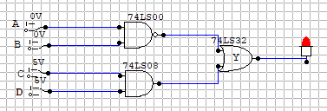

**Lab Task 2:**

1. Reduce the Boolean expression given below (on page)
$F\left(A,B,C\right)=\underline{A}B(C+ \underline{C}D)+B(A+\underline{A}CD)$

2. Write the reduced expression

A’BC+A’BC’D+AB+A’BCD

1. Create and fill the table for both expressions (given and reduced)

|  |  |  |  |  |  |  |  |  |  |  |  |  |
| --- | --- | --- | --- | --- | --- | --- | --- | --- | --- | --- | --- | --- |
| A | B | C | D | A’ | B’ | C’ | D’ | A’BC | A’BC’D | AB | A’BCD | X |
| 0 | 0 | 0 | 0 | 1 | 1 | 1 | 1 | 0 | 0 | 0 | 0 | 0 |
| 0 | 0 | 0 | 1 | 1 | 1 | 1 | 0 | 0 | 0 | 0 | 0 | 0 |
| 0 | 0 | 1 | 0 | 1 | 1 | 0 | 1 | 0 | 0 | 0 | 0 | 0 |
| 0 | 0 | 1 | 1 | 1 | 1 | 0 | 0 | 0 | 0 | 0 | 0 | 0 |
| 0 | 1 | 0 | 0 | 1 | 0 | 1 | 1 | 0 | 0 | 0 | 0 | 0 |
| 0 | 1 | 0 | 1 | 1 | 0 | 1 | 0 | 0 | 1 | 0 | 0 | 1 |
| 0 | 1 | 1 | 0 | 1 | 0 | 0 | 1 | 1 | 0 | 0 | 0 | 1 |
| 0 | 1 | 1 | 1 | 1 | 0 | 0 | 0 | 1 | 0 | 0 | 1 | 1 |
| 1 | 0 | 0 | 0 | 0 | 1 | 1 | 1 | 0 | 0 | 0 | 0 | 0 |
| 1 | 0 | 0 | 1 | 0 | 1 | 1 | 0 | 0 | 0 | 0 | 0 | 0 |
| 1 | 0 | 1 | 0 | 0 | 1 | 0 | 1 | 0 | 0 | 0 | 0 | 0 |
| 1 | 0 | 1 | 1 | 0 | 1 | 0 | 0 | 0 | 0 | 0 | 0 | 0 |
| 1 | 1 | 0 | 0 | 0 | 0 | 1 | 1 | 0 | 0 | 1 | 0 | 1 |
| 1 | 1 | 0 | 1 | 0 | 0 | 1 | 0 | 0 | 0 | 1 | 0 | 1 |
| 1 | 1 | 1 | 0 | 0 | 0 | 0 | 1 | 0 | 0 | 1 | 0 | 1 |
| 1 | 1 | 1 | 1 | 0 | 0 | 0 | 0 | 0 | 0 | 1 | 0 | 1 |

1. Implement both the expressions (given and reduced) in Circuit Maker with same inputs (only three common inputs A, B and C) and verify your results.

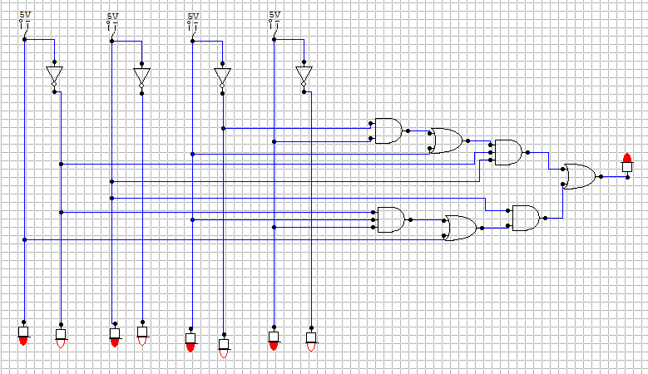

1. Implement both the expressions (given and reduced) on Explorer Board and verify your results with circuit maker.

**Lab Task 3:**

1. Reduce the Boolean expression given below (on page)
$F\left(A,B\right)= A(A + B) + (B + AA)(A + B)$

2. Write the reduced expression

Y=A+B

1. Create and fill the table for both expressions (given and reduced)

|  |  |  |  |  |
| --- | --- | --- | --- | --- |
| A | B | A+B | A(A+B) | (A+B) (A+B) |
| 0 | 0 | 0 | 0 | 0 |
| 0 | 1 | 1 | 0 | 1 |
| 1 | 0 | 1 | 1 | 1 |
| 1 | 1 | 1 | 1 | 1 |

1. Implement both the expressions (given and reduced) in Circuit Maker with same inputs (only three common inputs A, B and C) and verify your results.
2. Implement both the expressions (given and reduced) on Explorer Board and verify your results with circuit maker.

**Lab Task 4: The task contains 3 parts.**

1. We have to control an LED with the help of three switches A, B and C. However, there are some conditions as mentioned below;

* LED will be only switched on if all the switches A, B and C are on
* LED will on if A and B are on whereas C is off
* LED will on if only C is on whereas A and B are off
* LED will be off, otherwise

1. Write Boolean expression for the above problem
2. Write the simplified Boolean expression for the above problem
3. Implement both the expressions (given and reduced) in Circuit Maker with same inputs (only three common inputs A, B and C) and verify your results.
4. We have to control an LED with the help of three switches A, B and C. However, there are some conditions as mentioned below;

* LED will be only switched on if all the switches A, B and C are off
* LED will on if C and A are on whereas B is off
* LED will on if only B is on whereas A and C are off
* LED will be off, otherwise

1. Write Boolean expression for the above problem
2. Write the simplified Boolean expression for the above problem
3. Implement both the expressions (given and reduced) in Circuit Maker with same inputs (only three common inputs A, B and C) and verify your results
4. We have to control an LED with the help of three switches A, B and C. However, there are some conditions as mentioned below;

* LED will be only switched on if all the switches are off
* LED will on if C or A are on whereas B is off
* LED will on if C or B are on whereas A is off
* LED will on if only B or C is on
* LED will be off, otherwise

1. Write Boolean expression for the above problem
2. Write the simplified Boolean expression for the above problem
3. Implement both the expressions (given and reduced) in Circuit Maker with same inputs (only three common inputs A, B and C) and verify your results

**Lab Task 5: Draw simplified equivalent circuit for the given schematic. Write original expression, simplified expression, truth table and draw its reduced circuit on circuit maker to complete the task.**

**A)**

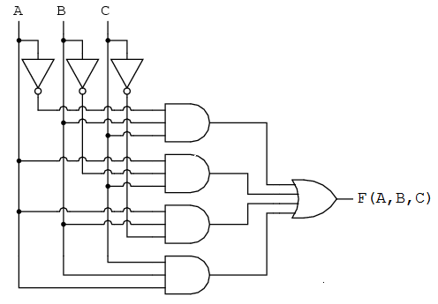

**B)**

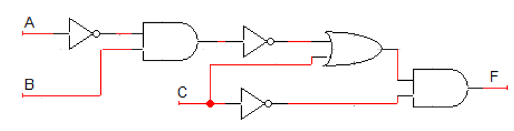

**C)**

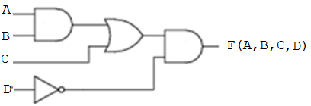

**Lab Task 6:**Consider the given expression and find the missing block

$F\left(A,B,C\right)=\underline{A}BC . (A+B+\underline{C})$

